2 STATIC ELECTRICITY
Whether there is static electricity in a plastic pen can be found out by putting it near some flakes of aluminium foil or tiny pieces of paper. ² If there is a charge in the pen, it will pull them towards it. ³ If there isn't a charge in it, it won't attract them. ⁴ one way to put an electric charge into a plastic pen is to rub its end in fur. ⁵ Wool or your own hair will do. ⁶After you do this, it will attract the flakes or pieces of paper.
⁷ If you suspend a plastic pen that has been rubbed in fur and then put another plastic pen that has also been rubbed in fur near it, it will push it away. “This is because both pens have negative electric charges. ⁹ If you rub a plastic pen in polythene, it gets a positive charge. ¹⁰ When you put it near the negatively charged pen, it pulls it towards it. ¹¹ Thus two negatively charged pens push each other away, but a negatively charged pen and a positively charged pen pull towards each other. ¹² Two pens which have been given positive charges by rubbing them in polythene, also push away from each other. ¹³ so you can see that when pens with the same type of charge are put together, they repel each other. ¹⁴ On the other hand, two pens with different electric charges attract each other. ¹⁵ The general conclusion from these facts is that like charges repel each other, but unlike charges attract each other.
New words and expressions

- Static (adj) = not moving
- Static electricity ['stætik ilek'trisiti] (u) =
sự tĩnh điện (điện tích lũy trên hoặc trong một vật không dẫn điện) (như) static
[uncount] = electricity that does not flow in a current but is found in certain objects when they rub together and can give an electric shock.
- Whether ['weðə] conjunction = used when someone does not know which of two possibilities is true:
They asked us whether we were married.
There is some doubt as to whether the illness is infectious.
whether...or: She doesn’t even know whether her daughter is dead or alive.
whether or not: I still don’t know whether or not he’s planning to come.

(dùng (như) chủ ngữ hoặc bổ ngữ của câu)
it's doubtful whether there'll be any seats left (không biết là liệu có còn chỗ ở rạp hay không)
the question is whether to go to Munich or Vienna (vấn đề là đi Munich hay đi Vienna)
whether they win or lose is all the same to me
( đối với tôi, họ thắng hay bại thì cũng như nhau thôi (đối với tôi, họ thắng hay bại (cũng) chắng có nghĩa gì)

whether or not (dù... hay không)
whether or not it rains/whether it rains or not, we're playing football on Saturday
(dù trời có mưa hay không, đến thứ bảy chúng tôi vẫn chơi đá bóng)
tell me whether or not you're interested (hãy cho tôi biết dù anh có thích hay không)
I'll be happy whether or not I get the job (tôi vẫn vui dù tôi có được giao công việc này hay không)

- Find (v) = discover (by searching)
- Flake [fleik] (n) = a small flat piece of something: wheat flakes
a flake of snow
- Flake off (v) = 1. flake or flake off [intransitive] to come off a surface in small flat pieces:
Her skin was itchy and beginning to flake. (roi la ta)
2. [intransitive or transitive] if food such as fish flakes or you flake it, it breaks easily into small flat pieces

- Aluminum [,ælju'minjəm] (u) = a light silver colored metal that is used, for example, to make cans, symbol: Al cooking equipment, and aircraft parts: an aluminum can
= metal rolled into (can dep)very thin sheets

Cách viết khác : aluminum [ə'lu:minəm] (nhôm)

- Al,uminum’ foil [uncount] = a very thin light sheet of shiny metal that you can wrap food in to keep it fresh (lá nhôm) / metal rolled into very thin sheets.
(cán dẹp)

- Charge [t∫ɑ:dʒ] [count] = the amount of electricity that something holds or carries:
(dien tich; su nap dien)
● The proton has a positive electrical charge.
(v) = charge or charge up [intransitive or transitive] to put electricity into a piece of ● electrical equipment such as a BATTERY:
● The phone won’t work if it isn’t charged up.
- Charger (n) = a piece of equipment used for providing a BATTERY with electricity (dụng cụ sạt điện)

- Towards [tə'wɔ:dz] Cách viết khác : toward [tə'wɔ:d] ( preposition) = In a particular direction used for saying in which direction someone or something is going, facing, or looking:
● a stream of traffic speeding toward the city
● I saw Joanna hurrying toward me along the sidewalk.
- Pull ‡ Push = hút ‡ đẩy → Pull towards (về phía) ‡ Push away

- Attract [ə'trækt] (v) = (vật lý) hút ; thu hút, hấp dẫn, lôi cuốn
● magnet attracts iron (nam châm hút sắt)
● to attract attention (lôi cuốn sự chú ý)

Plastics

Thermo ['θə:mo(u)-] thermosetting [,θə:mou'setiη]

PCV polythene nylon melamine
( Polyvinyl Cloride) ( a type of plastics:
Flexible → can be bent easily
Transparent → can see sth. through it)

- PVC = polyvinyl chloride: a type of plastic used for making clothes, shoes, WATER PIPES, etc.:
a black PVC raincoat.

- Rub [rʌb] (v) = to press and move one object against another or against a surface:
rub something together:
● Rub your hands together, it will help you to stay warm.
rub something against something:
● The cat rubbed its cheek against my leg.

- End (v) = to make something reach its final point / finish
(n) = At the end ≠ at the beginning of the month.

- Fur [fə:] (n) = bộ lông mao; bộ lông thú; bộ da lông thú
● a fox fur (bộ da lông cáo)
● a fur coat (áo choàng làm bằng da lông thú)
In fur = da có lông của động vật

Coverings ( lớp phủ ngoài) bone (xương)
Flesh (thịt)
skin
fur, hair (lông mao), feather (lông vũ), scales (vẩy cá)

- Wool [wul] (u) = thick hair that grows on sheep and some other animals
- Suspend [sə'spend] (v) = to hang something from something else: (treo len)
● A huge chandelier was suspended above the table.
● They suspended him by his feet.
- Negative ['negətiv] (adj) = with the same electrical charge as an ELECTRON
● a negative charge ( dien tich am)
- Positive ['pɔzətiv] (adj) = a positive number is higher than zero
● a positive charge (điện tích dương)
- Electric (adj) = working by electricity:
● an electric motor/drill/razor/toothbrush
● houses without electric light
1a. used for carrying electricity:
● an electric outlet/plug/cord
1b. relating to electricity:
● an electric current
2. extremely exciting:
● The atmosphere here tonight is absolutely electric.
- Electrical (adj) = working by electricity:
● They sell all kinds of electrical equipment and appliances.
a. relating to electricity:
● The fire was caused by an electrical fault.
● electrical engineering
* Note:
Electric (adj) describes things that use electricity to make them work
● an electric iron / shaver / guitar / cooker. Ect.
Electrical (adj) is used in more technical context when referring to the manufacture or use of electricity
● electrical wiring
● an electrical engineer
Electrical is also used with general nouns when referring to things that are powered by electricity
● Electrical equipment
● an electrical appliance

- Electric charge [i'lektrik't∫a:dʒ] = điện tích
- Polythene ['pɔliθi:n] = a type of plastics widely used in the form of flexible, often transparent.
( Politen (một loại nhựa tổng hợp được dùng dưới dạng lá mềm dẻo, trong suốt chống thấm nước, cách điện..)
- Negatively charged = duoc nap dien am
- So = thus = therefore = hence (vi vay; do do)
- Repel [ri'pel] (v) = repulse [ri'pʌls] (day)
= SCIENCE if one thing repels another, an electrical or MAGNETIC force pushes them away from each other
- On the other hand (expression) = mặt khác
- Conclusion [kən'klu:ʒn] (n) = [count] something you decide is true after thinking about it carefully and looking at all the evidence. (sự kết luận, phần kết luận)

- Like (adj) dislike = the same (as) ‡ different (from) = similar (to / from / with) ‡ dissimilar
- Fur [fə:] (u) = the soft hair that covers the body of some animals: (lông mao)
● the dog’s thick glossy fur
- Feather ['feðə] = one of the narrow tubes with thin soft hairs on each side that cover a bird’s body
a. [only before noun] filled with feathers: (lông chim, lông vũ)
● a feather bed/pillow/ (duvet ['dju:vei] = chăn/mềm lông vịt)
- Flake (c) = a small flat piece of something

COMPREHENSION

1. How can you find out static electricity in a plastic pen?
→ Rub its end in fur then put it near some flakes of aluminium foil ir tiny piece of paper.
2. What happens / will happen if there is a charge in the pen that is put near some flakes of aluminium or tiny piece of paper?
→ It will pull them towards it.
3. How do you put an electric charge into a plastic pen?
→ Rub its end in fur or wool or your own hair.
5. What happens if you rub the end of a plastic pen in fur?
→ It gives a negative charge / it will attract some tiny things that is put near it.
6. What happens if you rub the end of a plastic pen in polythene?
→ It gets a positive charge. / it pulls towards some tiny things to it.
7. What is the result of two pens that are rubbed in fur?
→ They will push away from each other.

I. MATCHING
A B
1) attract a) fur
2) animal hair b) different
3) tiny pieces c) push away
4) repel d) flakes
5) dissimilar e) pull towards

KEY 1(e) 2(a) 3(d) 4(c) 5(b)

II. TRUE / FALSE
1. If a plastic rod attracts aluminium flakes, it has an electric charge in it. (T)
2. We can put an electric charge into a plastic rod. (T)
3. Rubbing a plastic rod with hair or fur gives it a positive charge. (F)
4. Polythene and wool give a plastic rod the same type of charge. (F)
5. Rods rubbed in the same material will attract each other. (F)
6. A pen with a positive charge will attract another one with a positive charge. (F)
7. Positive charges attract negative charges but repel other positive charges. (T)

III. COMPLETING SENTENCES

- Al,uminum `foil [uncount] = a very thin light sheet of shiny metal that you can wrap food in to keep it fresh
- Thus [ðʌs] (adv) = as a result of the fact that you have just mentioned: THEREFORE, HENCE:
● Fewer pupils will attend the schools, and they will thus have fewer teachers.
● Someone had removed all the evidence. Thus, it was now impossible for the police to continue their investigation.

Complete these sentences using words from the reading passage.
The completed sentences explain why the statements in Exercise II are correct or incorrect.

l. Statement 1 is correct because it says in the Reading Passage that if a pen has an electric
charge in it, it will attract flakes of aluminium foil or tiny pieces of paper. If there isn't a charge
in the pen, it won't atttract the flakes of aluminium foil or tiny pieces of paper. Therefore if a
plastic rod attracts aluminium flakes, it has an electric charge in it.

2. The second statement is also correct. An electric charge can be put into a plastic pen by
rubbing it in fur. It shows that it has an electric charge because it then attracts flakes
of aluminium foil. Thus, we can put an electric charge into a plastic pen.

3. This statement is incorrect according to sentences 7 and 8 in Reading Passage 1 .
A plastic pen which has been rubbed in fur pushes away another pen rubbed in fur because
both pens have negative charges.
Therefore, rubbing a plastic rod with hair or fur gives it a negative charge.

- This statement must be incorrect because sentences 7 and 8 say that a pen rubbed in fur,
takes a negative charge. Wool is a type of fur . In sentence 9 it says that a pen rubbed
in polythene takes a positive charge.
Therefore, polythene and wool give a plastic rod different types of charges.

5. This is another incorrect statement. In sentence 7 it says that two pens rubbed in fur will push
away from each other. This means that rods rubbed in the same material will push away from
each other.

- This is also wrong because it says in sentence 12 that pens which have been given positive
charges by rubbing them in polythene, will push away from each other .
Therefore, a pen with a positive charge will push away from another one with a positive charge.

- This is a correct statement. It states in sentence 13 that when pens with the same type of
charge are put together they repel each other. In sentence 14 it states that two pens with
different charges attract each other.
Therefore positive charges attract negative charges but repel other positive charges.

IV. SUBSTITUTION

l. In sentence 2, them substitutes for :
a) the plastic pen.
b) flakes of aluminium foil.
c) both fakes of aluminium and paper.

2. ln sentence 3, it substitutes for:
a) the plastic pen.
b) the aluminium.
c) the electricity.

3. In sentence 6, this substitutes for:
a) attract the flakes of aluminium.
b) rub the end of the pen in fur.
c) put an electric charge into the pen.

4. In sentence 7, the first it substitutes for :
a) the suspended pen.
b) the pen just rubbed in fur.
c) a pen that hasn't been rubbed in fur.

5. In sentence 7, the third it substitutes for:
a) the suspended pen.
b) the pen just rubbed in fur.
c) a pen that hasn't been rubbed in fur.

6. In sentence 10, the third it substitutes for:
a) the positively charged pen.
b) the negatively charged pen.

7. In sentence l3, they substitutes for:
a) two pens with the same charge.
b) two negatively charged pens.
c) two pens with different charges (positive, negative).

V. EXPLAINING SYMBOLS

- Copy the symbols in Fig . 2. into your notebook and beside each write an explanation
of what it means.
- When you have explained them, write the general conclusion which they indicate.

______________________________________________
Fig. 2.1 Attraction and repulsion
______________________________________________

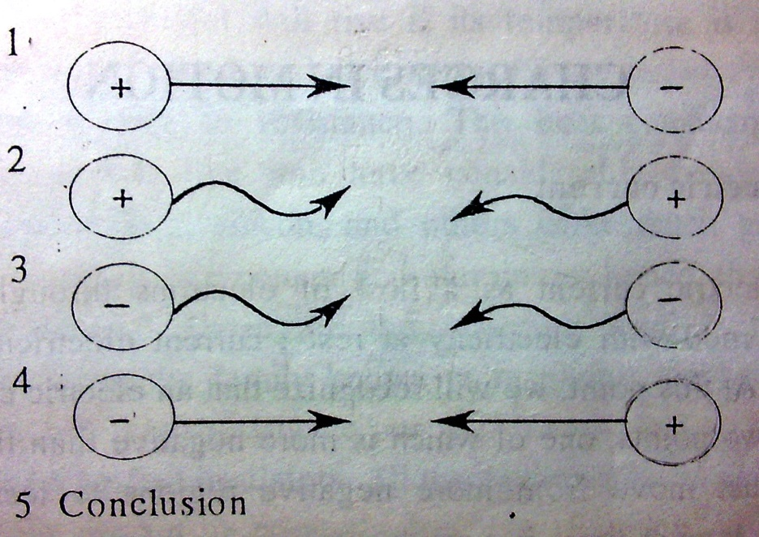

Key 1. attract 2. push away 3. push away 4. attract
5. Conclusion : like charges repel each other, but unlike charges attract each other.

VI . Grammar

Sentence: a group of words, usually including a subject and a verb that express a statement, question,
or instruction. A written sentence begins with a capital letter and ends with a period, question mark, or
exclamation point.
Don’t let anyone tear your dream away!
What’s your major?
I love you more than I can say.

Clause:
A group of words that includes a verb and a subject and is a sentence or a main part of one.
If you put a plastic pen in polythene, it gets a positive charge.

Phrase: a group of words.
A bomb exploding / yesterday morning

Conditional sentences

- Conditions
An if-clause refers to a condition – something which must happen so that something else can
happen.
If you get here before eight, we can catch the early train.

There are two parts of a conditional sentence :

If you love me, let me know.
If you don’t . . . , let me go.

if clause / main clause

subordinate clause

An if-clause can come at the beginning or end of a sentence. When an if- clause comes first, it is
often separated by a comma.

2. Structures

Type 0 : general truths , habits

If-clause: V → simple present, main clause: V → simple present

If you put two negatively charged pens together, they repel each other.
Oil floats if you pour it on water.
Iron goes red when it gets very hot.

TYPE 1: Real conditions in the present or in the future.

If-clause: V → simple present , main clause: V → simple future
Note
Simple future
(+) S + will + bare verb + O
(-) S + won’t + bare verb + O
(?) Will + S + bare verb + O ?
(Wh-) + Will + S + bare verb + (O ) ?

Tom: I think I left my wallet on your table. Have you seen it?
Ann: No, but I’ll have a look. If I find it, I’ll give it to you.

If it doesn’t rain, I will have a picnic.
What will you do if you win a million dollar in the lottery?

TYPE 2 : Unreal conditions in the present or future.

If-clause: V → past subjunctive (V2) , main clause: V → would
BE (were) for all persons. could + bare verb
might

If I were a bird, I could fly through the sky. (I’m not a bird)
You would pass the exam if you studied hard. ( you don’t study hard)
What would you do if you lost your job?

TYPE 3 : Unreal conditions in the past ( unreal past situations)
To talk about past situations that didn’t happen.
If-clause: V → past perfect subjunctive ( had + V3),
Main clause: V → would
could + have + past participle
might
If I had known your address, I would have sent you a postcard.
( but I didn’t know your address)

If the semester had ended a week earlier, I could have gone to New York with my
parents.

If you had worked harder, you would have pass your exam.
( you didn’t work hard)

